Hach JOB Cal® Plus

Quick Start Guide

OVERVIEW
Hach JOB Cal® is a computerized maintenance management program that assists you in your maintenance operations. There are two products in the JOB Cal family. Hach JOB Cal Basic provides the basic functionality of managing your calendar and work orders. Hach JOB Cal Plus, which is the focus of this turorial, adds inventory, purchasing, vendor and labor tracking. It also integrates and displays equipment drawings, pictures and instructions.

The Calendar is the heart of the JOB Cal system. It displays all the work to be done, completed work, and overdue work for a sliding 52-week period. Jobs can be closed, rescheduled, deleted, skipped, and created using the calendar.

Key terms to know:
- A Work Order and a Job are the same thing - work to be done on a specific piece of equipment for a specific date.
- A task is a function to be performed - for example, “Perform Calibration” would be a task.
- You perform tasks on the equipment
Once you have a task set up, you assign pieces of equipment to the task. For example, you could assign a truck and a car to the task “Change Oil”. When you assign equipment to a task, you set up a schedule of when you want the task performed on that equipment. For example, the truck would be scheduled every 5000 miles and the car would be scheduled every 90 days.

Hach JOB Cal Plus Tutorial
The following instructions will take you through the basic steps of entering equipment, entering a task, entering employee information, printing and closing a Work Order. Then you will be ready to set up your database.

If you need assistance at any time please contact us at 1-800-677-0067 or at imsupport@hach.com.

STEP 1: Install Hach JOB Cal Plus
This step will install a single user. If you require a network setup please refer to the manual Chapter 1 or call support.
- Close any programs currently running.
- Place the JOB Cal DVD into your DVD drive.
- The Hach JOB Cal Installer should begin immediately (within 15 seconds), or browse to “D:\Launcher” where D is your DVD drive, and double click on Launcher.hta to start the installer.

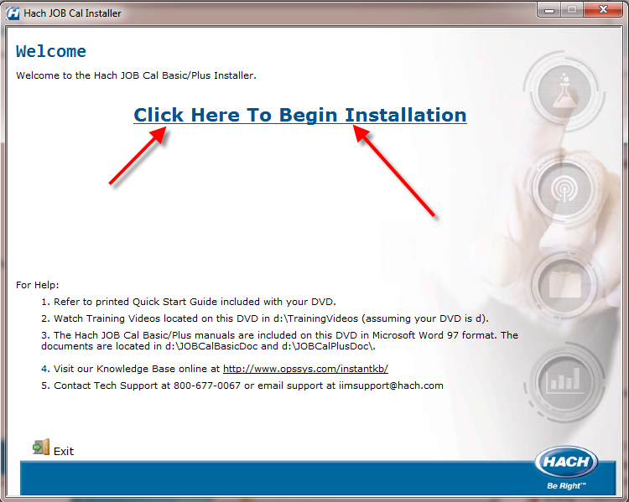

- Click on the Click Here to Begin Installation link.

- Enter your Serial #, referred to as the “software license serial”, located on the inside cover of the JOB Cal DVD case. Click OK.

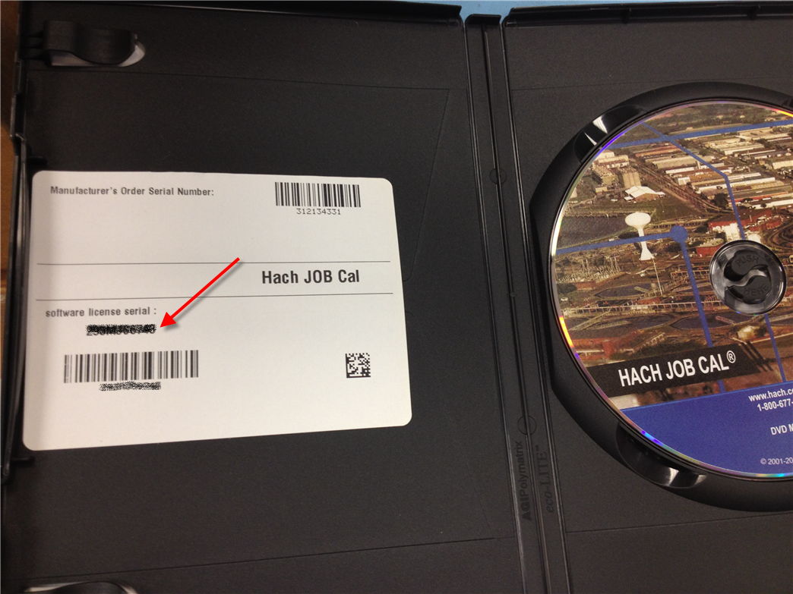

- Follow the instructions on the screen, when the installation program displays the following box, click OK.
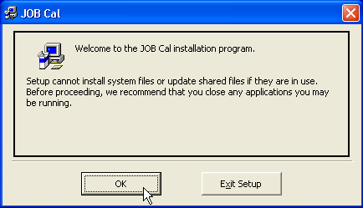

- The following screen will be displayed. Click the Install button to continue.
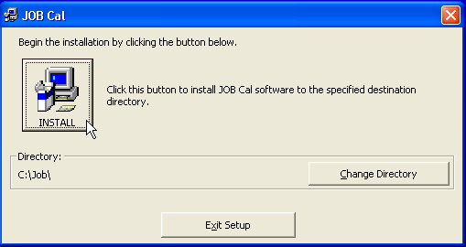

- Follow the instructions on the screen to complete the installation.

Two sample databases are created when you install the program, JobPlus.mdb and Tutor.mdb. Tutor.mdb contains some example data and will be used in this tutorial; JobPlus.mdb doesn’t contain any data and can be used as your production database.

STEP 2: Start Hach JOB Cal Plus
- Click on Start, Programs, OPS Systems, JOB

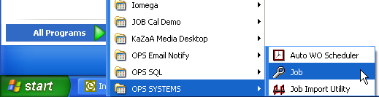

- Choose the Tutorial database from the list and click OK

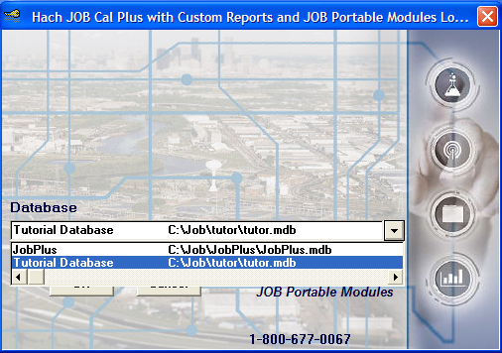

STEP 3: Enter Equipment
Equipment is any item (pumps, valves, vehicles, buildings, pipe lateral, anything) you want to track. Each piece of equipment needs a unique set of numbers and/or letters to identify it. If you do not have an existing equipment numbering scheme use simple abbreviations.

Using the Tutorial database, enter a piece of equipment.
- Click the Equipment Entry button

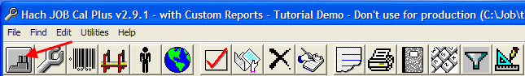

- Click the Add New button

- Fill in the form with the following:
  - Equipment #: = 10-RP2
  - Description: = RAS Pump #2
  - Equip. Type: = Pump
  - Click Save & Close button

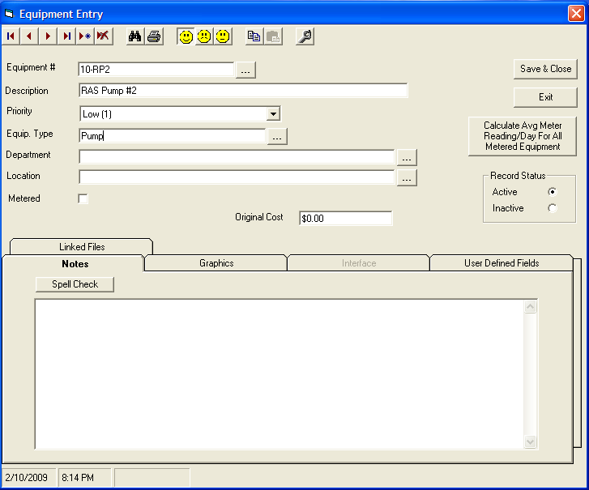

STEP 4: Enter Tasks
Tasks define the repetitive maintenance to be performed. For example, “Change Oil” in a car every three months is a task. The task records are used to build the JOB Calendar.

Using the Tutorial database, enter a task.
- Click the Task Entry Button 
- Click on the Add New button
- Fill in the form with the following:
  - Work Description: = Lube Pump
  - Est. Labor Hours: = 1
- Add Equipment to the Task. Click on the Add 1 Equipment button.
  - Click and choose 10-RP2 from the list. You can double click on 10-RP2 or click OK after selecting.
  - Schedule by: = Floating
  - Frequency in Days: = 7
  - First Due Date: = (choose 3 days from today’s date)
  - Click OK.
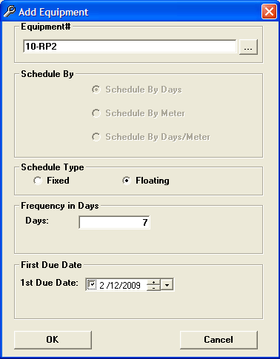
- Enter task instructions
  - Click on the tab.

  - Enter Instructions: = Grease 3 Fittings

- Click Save & Close button and the WO will be added to the calendar.

- Find the JOB you just created. It is an aqua color.

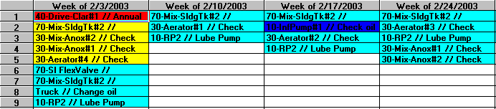

STEP 5: Employees

Step 5a: Setting Up Employees

Employee information is used by Hach JOB Cal Plus to assign jobs (work orders) to personnel and to track labor.

- Click on the employee icon  on the toolbar.

- Fill in the employee number – this is a required field. If you do not track employee numbers just use their initials.
- Enter the employee name – all other fields are optional
- The graphics field can be used for employee pictures if desired (uploading graphics is an advanced topic and can be found in the JOB Cal Plus documentation)

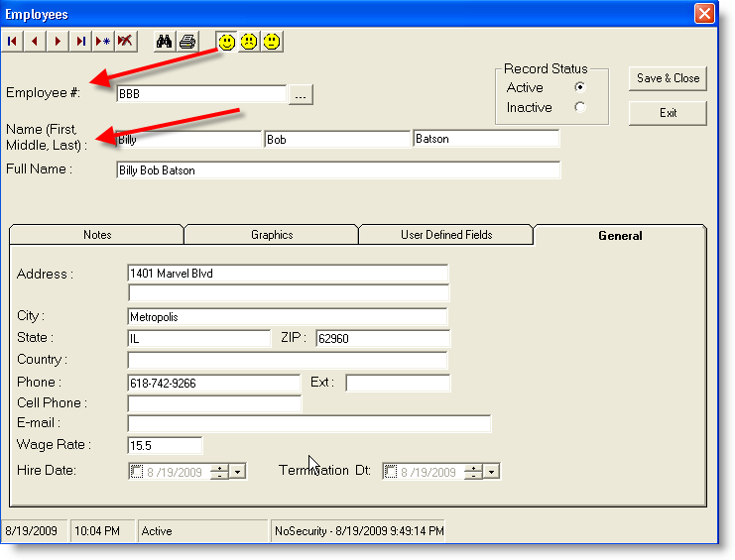

Step 5b: Assigning Employees to Work Orders

- Click on the work order and click on the drop down button “…” and chose the employee. This can be done when the task is first set up or at any later time. (Note with JOB Cal Plus you have an expanded work order window where you can associate a number of items with a work order.)
- The employee name will be displayed in the Assigned To box

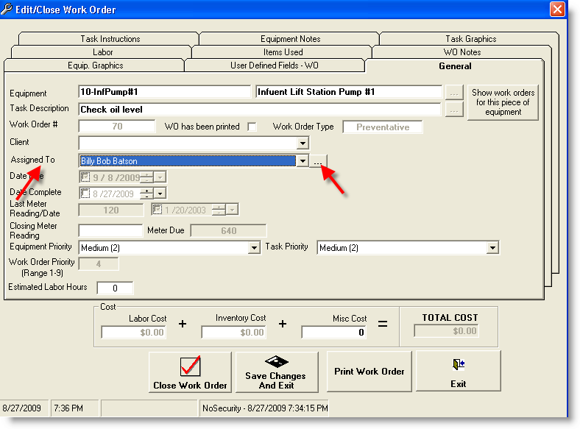

- Click Save changes and Exit and the person assigned to the work order appears at the bottom of the JOB Cal Plus page where work order details are shown

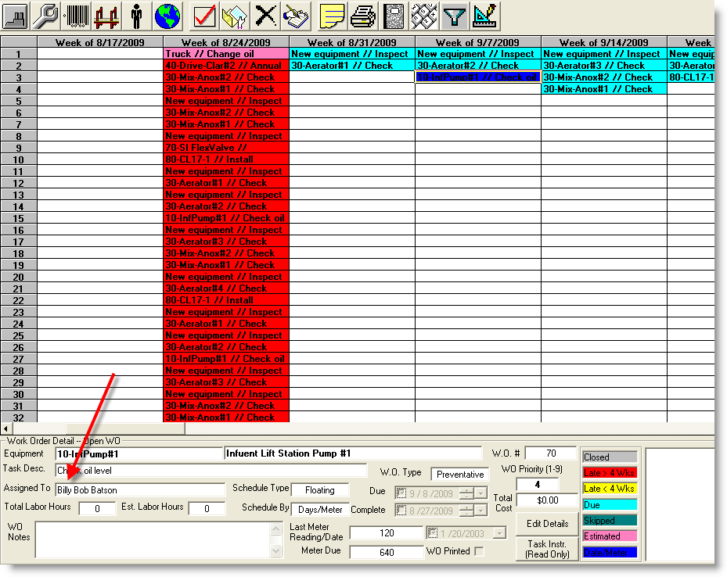

STEP 6: Setup Inventory

Use this screen to add inventory items that will be needed for jobs.

- Click on the inventory icon to bring up the inventory screen 
- Fill in the inventory form with your inventory items like reagents, gaskets, oil, etc.
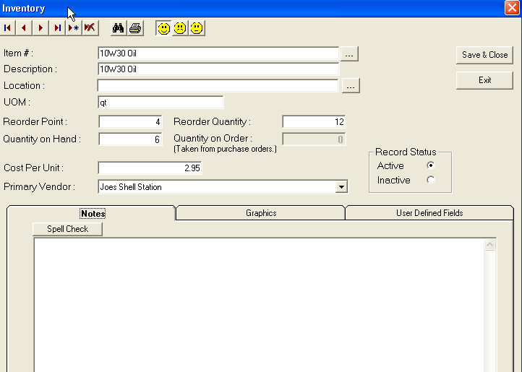
- Enter item # = 10w30 Oil
Enter item description = 10w30 Oil
Enter Unit of Measurement (UOM) = qt
Enter Reorder Point = 4
Enter Reorder Quantity = 12
Enter Quantity on Hand = 6
Enter Cost Per Unit = 2.95
Enter Primary Vendor = Joes Shell Station

Step 7: Setup Vendors

Enter information about vendors on this screen. Vendor information is mainly used for Inventory and Purchase Orders to track which vendor is providing consumables and other items.

- Click on the Vendor icon 

- Fill in the Vendor information and click save and close.

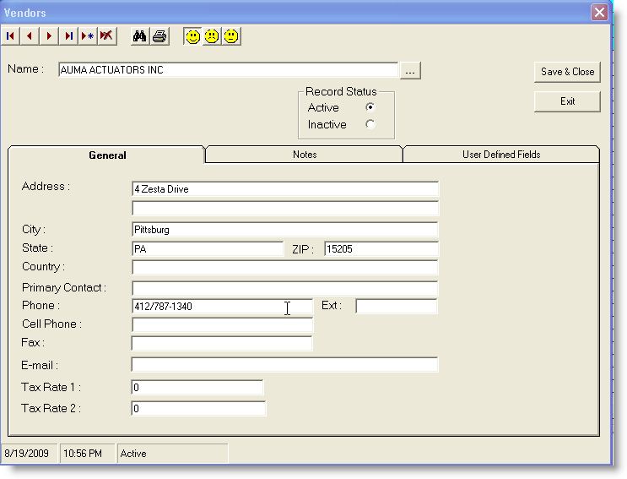
- Enter Vendor Name = Alma Actuators Inc
Enter Vendor Address = 4 Zesta Drive
Enter Vendor City = Pittsburg
Enter Vendor State = PA
Enter Vendor Phone # = 412/787-1340

STEP 8: Using the Calendar
The Calendar displays all the work to be completed work, overdue work, or skipped work for a streaming 56-week period. Jobs can be closed, rescheduled, deleted, and created using the calendar. To use the calendar, click on a job (cell) to make it current and then perform an action on the job (close, move, etc.). The current jobs' detail is displayed at the bottom of the screen. As you move around in the calendar, the detail will display information about the current job. The background color of a cell indicates the status of the Job.

To be done
Up to 4 weeks overdue.
Greater than 4 weeks overdue.
Job skipped. When a job is skipped it is moved to the history table.
Completed (closed).
Estimated job based on meter readings and the date due is estimated.
Date/Meter job scheduled by the date or meter reading (whichever comes first).

Entering Job Data for a Work Order in Progress
- To enter information pertaining to work done on a job before you are ready to close it, move to the job and double click on it.

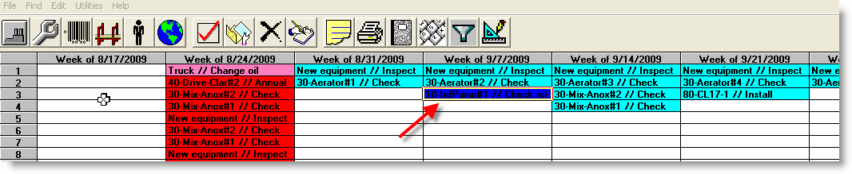

- Click on the Labor tab to bring up the entry screen

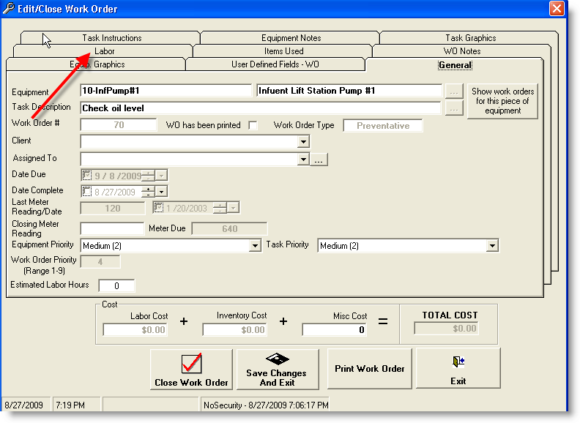

- Click on Add Labor to chose the employee that actually completed the task

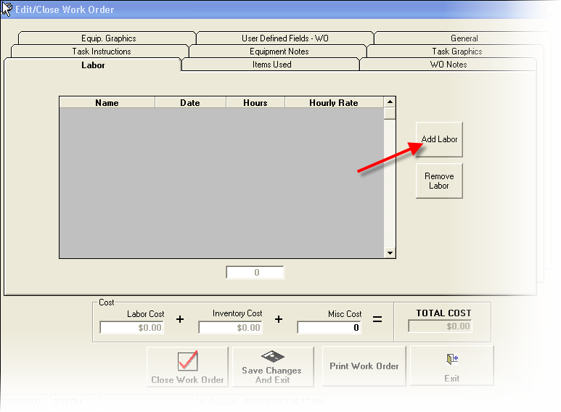

- From the list chose the employee for the task:
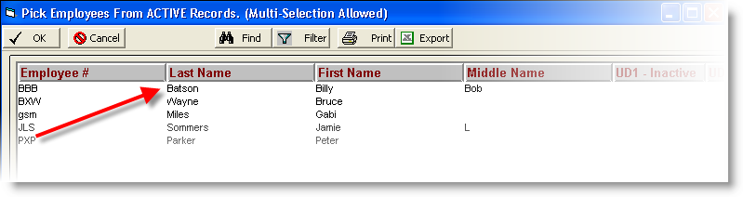

- Fill in hours and the hourly rate is automatically pulled from the employee record (if set up during employee setup).

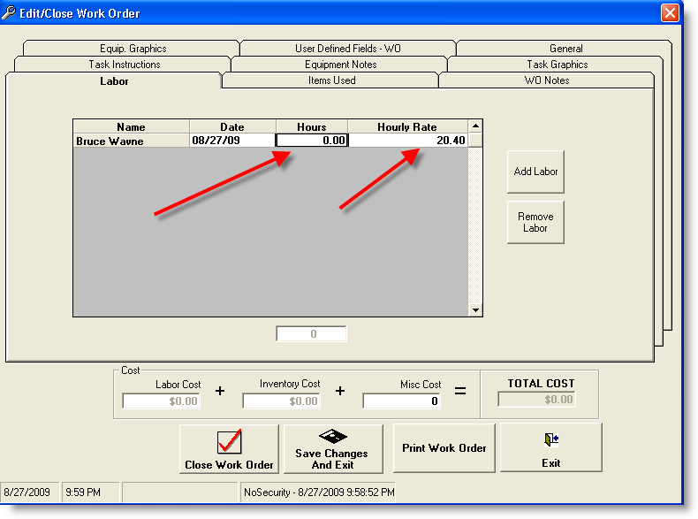

Click Save Changes And Exit button.

Step 9: Assigning Employees to Work Orders (also step 5b)

- Click on the work order and click on the drop down button “…” and chose the employee. This can be done when the task is first set up or at any later time. (Note with JOB Cal Plus you have an expanded work order window where you can associate a number of items with a work order.)
- The employee name will be displayed in the Assigned To box

- Click Save Changes and Exit and the person assigned to the work order appears at the bottom of the JOB Cal Plus page where work order details are shown

STEP 10: Printing Work Orders
- Click on an open Job(s) you want to print. Note: you cannot print a closed (i.e. gray) work order.
- Click the Print button on the toolbar. 

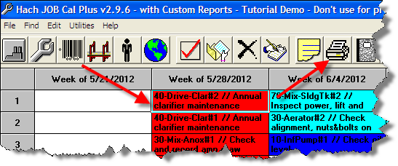

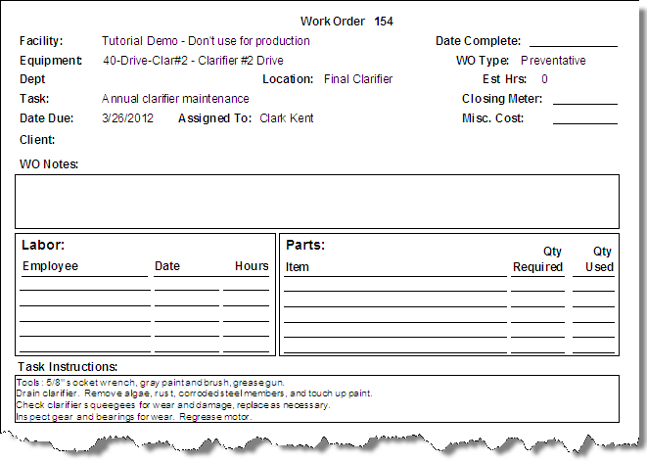

STEP 11: Close Work Order
After work on a job is complete, information about the job has been entered (hours worked, etc…) you can close a work order.

- Select the job on the calendar and double click on the work order.
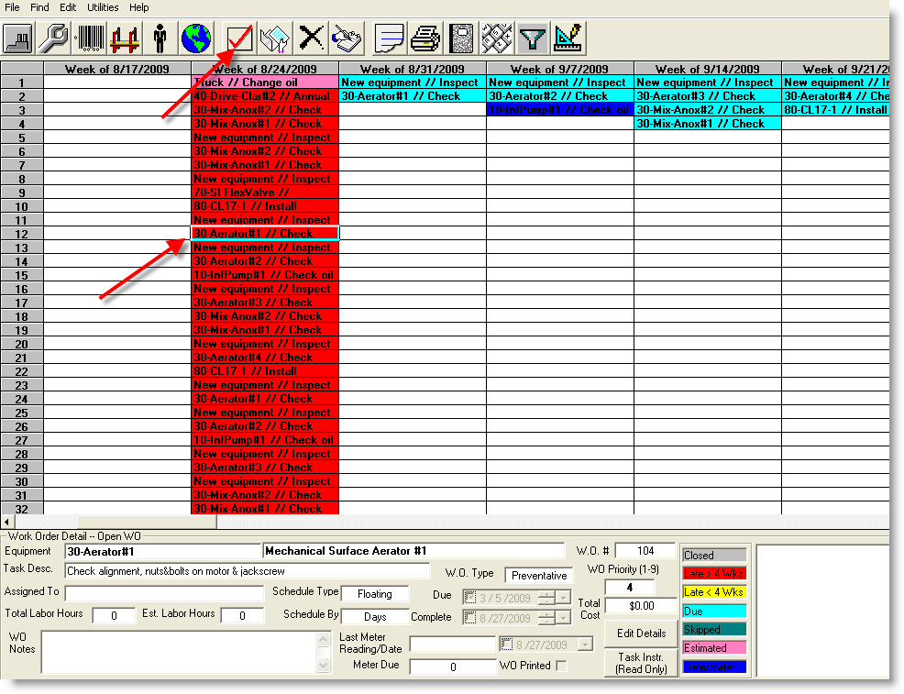

- The Work Order Close Form is displayed. Fill in the information and click the Close button on the form.

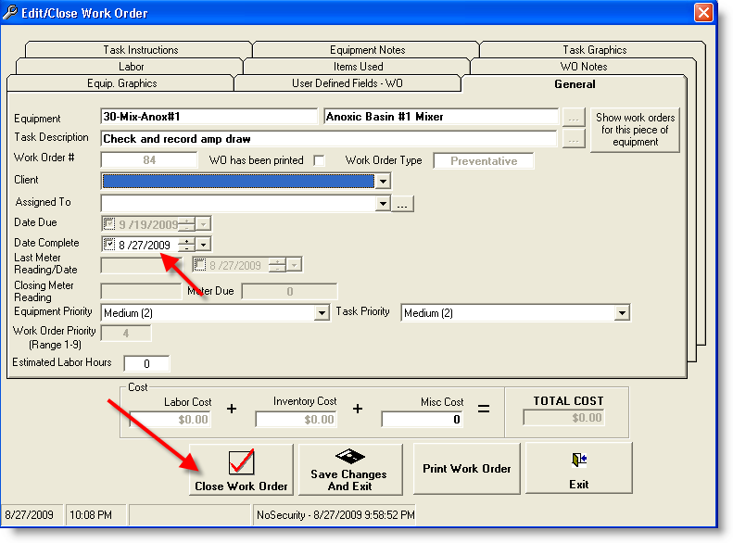

STEP 12: Reports

JOB Cal Plus allows you to print a number of reports. All reports are available from the report form.

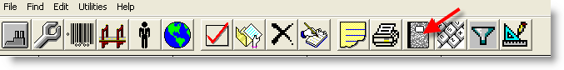

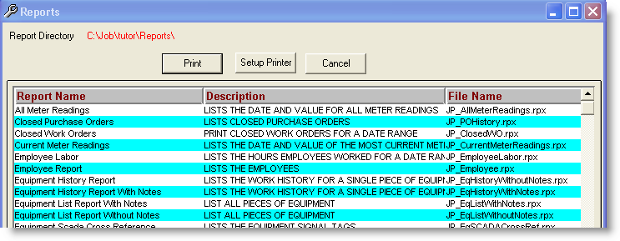

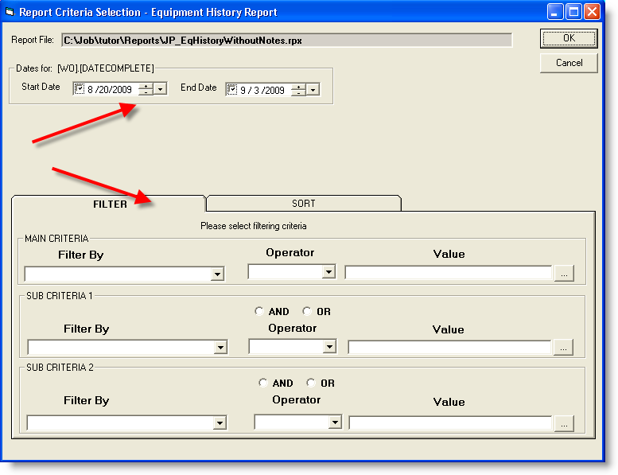

Job Cal Plus contains many more features and functions that are not covered in this tutorial. You will want to know more about fixed and floating schedules, metered equipment and reports, adding Purchase Orders and Graphics. You can find more information in several places.

- The online help. In JOB Cal Plus press the F1 key at any time to open the online help.
- Watch the training videos. The videos are located on the DVD in the \TrainingVideos folder or in the online help under Videos:
- The user manuals. The Hach JOB Cal Basic/Plus manuals are included on this DVD in Microsoft Word 97 format. The documents are located in d:\JOBCalBasicDoc and d:\JOBCalPlusDoc\.
- Contact Hach! Call our toll free line 800-677-0067 or email us at iimsales@hach.com

